**Name: Naheen Bijapure**

**Roll NO: 08**

**Question 1:**

**Write a JavaScript code to perform Light bulb on-off & text change all at once using the toggle button.**

<!DOCTYPE html>

<html>

<body>

<img id="myImage" onclick="changeImage()" src="pic_bulboff.gif" width="100" height="180">

<p>Click the light bulb to turn on/off the light.</p>

<script>

function changeImage() {

var image = document.getElementById('myImage');

if (image.src.match("bulbon")) {

image.src = "pic_bulboff.gif";

} else {

image.src = "pic_bulbon.gif";

}

}

</script>

<p><button onclick="myFunction()">Click Me</button></p>

<div id="myDIV">How are you???</div>

<script>

function myFunction() {

var x = document.getElementById("myDIV");

if (x.innerHTML === "How are you???") {

x.innerHTML = "I am Fine!!";

} else {

x.innerHTML = "How are you???";

}

}

</script>

</body>

</html>

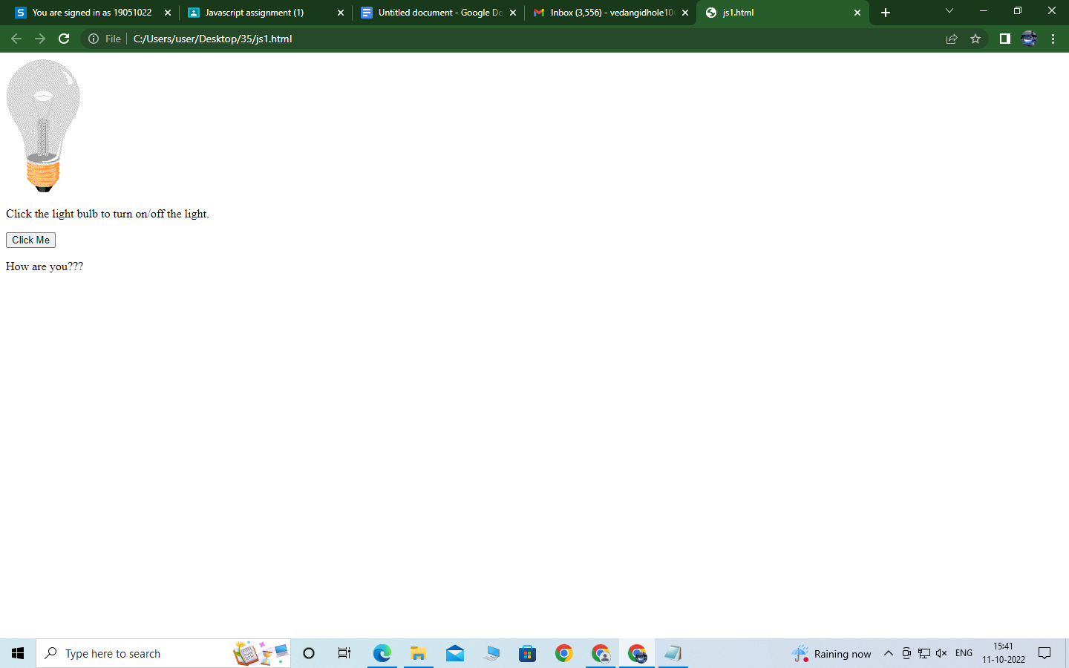

**Question 2:**

<!DOCTYPE html>

<html lang="en">

<head>

<meta charset="UTF-8">

<title>Simple HTML Form</title>

<link rel="stylesheet" href="style.css">

<script src="validator.js"></script>

</head>

<body>

<style>

body {

font-size: 16px;

background: #f9f9f9;

font-family: "Segoe UI", "Helvetica Neue", Arial, sans-serif;

}

h2 {

text-align: center;

text-decoration: underline;

}

form {

width: 300px;

background: #fff;

padding: 15px 40px 40px;

border: 1px solid #ccc;

margin: 50px auto 0;

border-radius: 5px;

}

label {

display: block;

margin-bottom: 5px

}

label i {

color: #999;

font-size: 80%;

}

input, select {

border: 1px solid #ccc;

padding: 10px;

display: block;

width: 100%;

box-sizing: border-box;

border-radius: 2px;

}

.row {

padding-bottom: 10px;

}

.form-inline {

border: 1px solid #ccc;

padding: 8px 10px 4px;

border-radius: 2px;

}

.form-inline label, .form-inline input {

display: inline-block;

width: auto;

padding-right: 15px;

}

.error {

color: red;

font-size: 90%;

}

input[type="submit"] {

font-size: 110%;

font-weight: 100;

background: #006dcc;

border-color: #016BC1;

box-shadow: 0 3px 0 #0165b6;

color: #fff;

margin-top: 10px;

cursor: pointer;

}

input[type="submit"]:hover {

background: #0165b6;

}

</style>

<script>

function printError(elemId, hintMsg) {

document.getElementById(elemId).innerHTML = hintMsg;

}

// Defining a function to validate form

function validateForm() {

// Retrieving the values of form elements

var name = document.contactForm.name.value;

var email = document.contactForm.email.value;

var mobile = document.contactForm.mobile.value;

var country = document.contactForm.country.value;

var gender = document.contactForm.gender.value;

var hobbies = [];

var checkboxes = document.getElementsByName("hobbies[]");

for(var i=0; i < checkboxes.length; i++) {

if(checkboxes[i].checked) {

// Populate hobbies array with selected values

hobbies.push(checkboxes[i].value);

}

}

// Defining error variables with a default value

var nameErr = emailErr = mobileErr = countryErr = genderErr = true;

// Validate name

if(name == "") {

printError("nameErr", "Please enter your name");

} else {

var regex = /^[a-zA-Z\s]+$/;

if(regex.test(name) === false) {

printError("nameErr", "Please enter a valid name");

} else {

printError("nameErr", "");

nameErr = false;

}

}

// Validate email address

if(email == "") {

printError("emailErr", "Please enter your email address");

} else {

// Regular expression for basic email validation

var regex = /^\S+@\S+\.\S+$/;

if(regex.test(email) === false) {

printError("emailErr", "Please enter a valid email address");

} else{

printError("emailErr", "");

emailErr = false;

}

}

// Validate mobile number

if(mobile == "") {

printError("mobileErr", "Please enter your mobile number");

} else {

var regex = /^[1-9]\d{9}$/;

if(regex.test(mobile) === false) {

printError("mobileErr", "Please enter a valid 10 digit mobile number");

} else{

printError("mobileErr", "");

mobileErr = false;

}

}

// Validate country

if(country == "Select") {

printError("countryErr", "Please select your country");

} else {

printError("countryErr", "");

countryErr = false;

}

// Validate gender

if(gender == "") {

printError("genderErr", "Please select your gender");

} else {

printError("genderErr", "");

genderErr = false;

}

// Prevent the form from being submitted if there are any errors

if((nameErr || emailErr || mobileErr || countryErr || genderErr) == true) {

return false;

} else {

// Creating a string from input data for preview

var dataPreview = "You've entered the following details: \n" +

"Full Name: " + name + "\n" +

"Email Address: " + email + "\n" +

"Mobile Number: " + mobile + "\n" +

"Country: " + country + "\n" +

"Gender: " + gender + "\n";

if(hobbies.length) {

dataPreview += "Hobbies: " + hobbies.join(", ");

}

// Display input data in a dialog box before submitting the form

alert(dataPreview);

}

};

</script>

<form name="contactForm" onsubmit="return validateForm()" action="confirmation.php" method="post">

<h2>Application Form</h2>

<div class="row">

<label>Full Name</label>

<input type="text" name="name">

<div class="error" id="nameErr"></div>

</div>

<div class="row">

<label>Email Address</label>

<input type="text" name="email">

<div class="error" id="emailErr"></div>

</div>

<div class="row">

<label>Mobile Number</label>

<input type="text" name="mobile" maxlength="10">

<div class="error" id="mobileErr"></div>

</div>

<div class="row">

<label>Country</label>

<select name="country">

<option>Select</option>

<option>Australia</option>

<option>India</option>

<option>United States</option>

<option>United Kingdom</option>

</select>

<div class="error" id="countryErr"></div>

</div>

<div class="row">

<label>Gender</label>

<div class="form-inline">

<label><input type="radio" name="gender" value="male"> Male</label>

<label><input type="radio" name="gender" value="female"> Female</label>

</div>

<div class="error" id="genderErr"></div>

</div>

<div class="row">

<label>Hobbies <i>(Optional)</i></label>

<div class="form-inline">

<label><input type="checkbox" name="hobbies[]" value="sports"> Sports</label>

<label><input type="checkbox" name="hobbies[]" value="movies"> Movies</label>

<label><input type="checkbox" name="hobbies[]" value="music"> Music</label>

</div>

</div>

<div class="row">

<input type="submit" value="Submit">

</div>

</form>

</body>

</html>

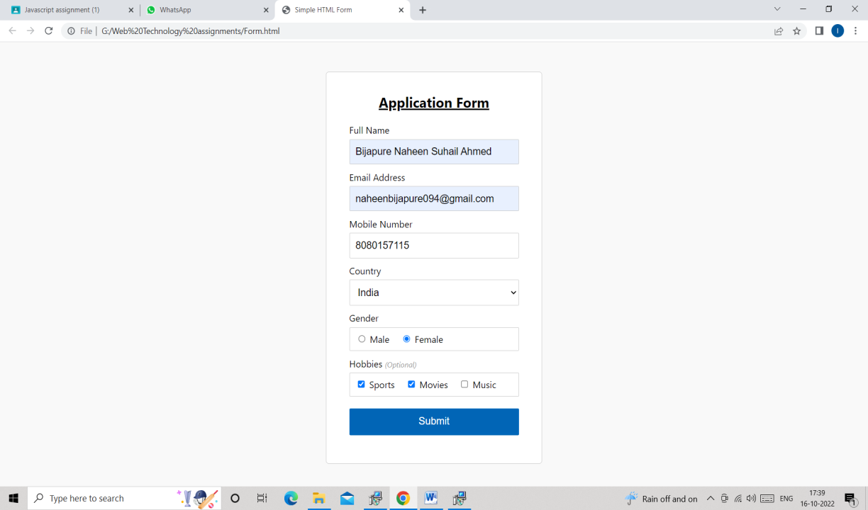

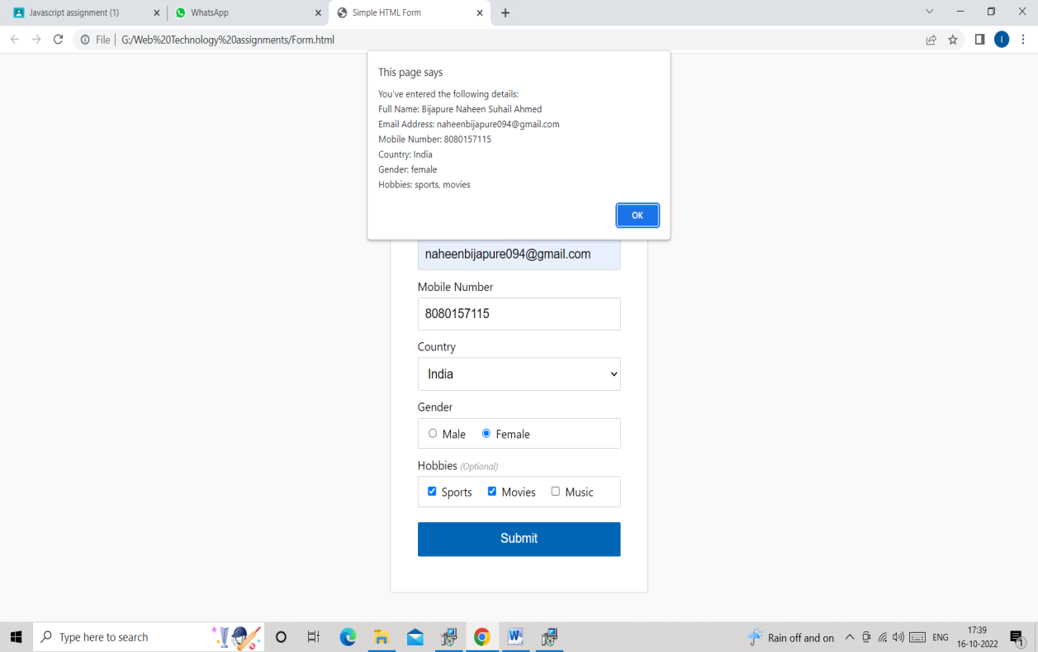

**Question 3:**

</html>

<!DOCTYPE html>

<html>

<body>

<h2 id="myH2">What is the html full form</h2>

<p id="myP">What is the CSS full form</p>

<p id="myP2">What is the js full form</p>

<div id="myDiv">What is the WT full form</div>

<br>

<button type="button" onclick="myFunction()">Set text color</button>

<script>

function myFunction() {

document.getElementById("myH2").style.color = "#ff0000";

document.getElementById('myH2').innerHTML= 'Hyper Text Markup Language';

document.getElementById("myP").style.color = "magenta";

document.getElementById('myP').innerHTML= 'Cascading Style Sheets';

document.getElementById("myP2").style.color = "blue";

document.getElementById('myP2').innerHTML= 'Java Script';

document.getElementById("myDiv").style.color = "lightblue";

document.getElementById('myDiv').innerHTML= 'Web Technology';

}

</script>

</body>

</html>

**Output:**

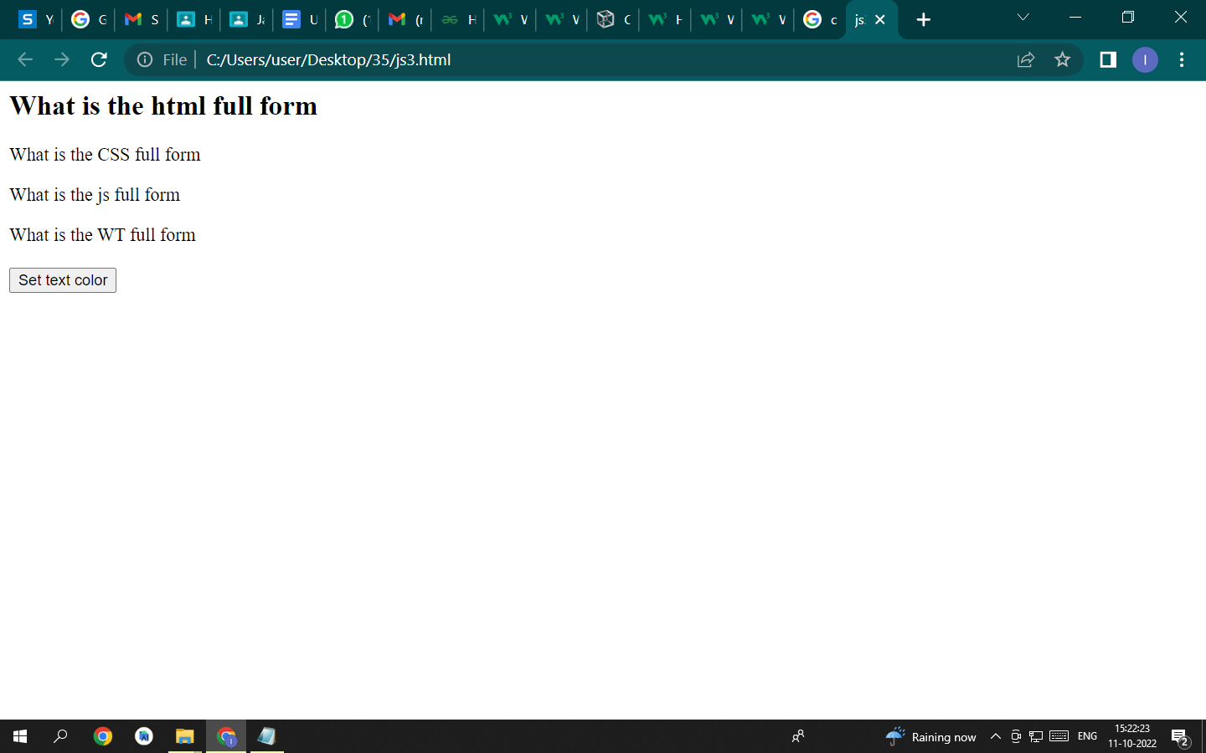

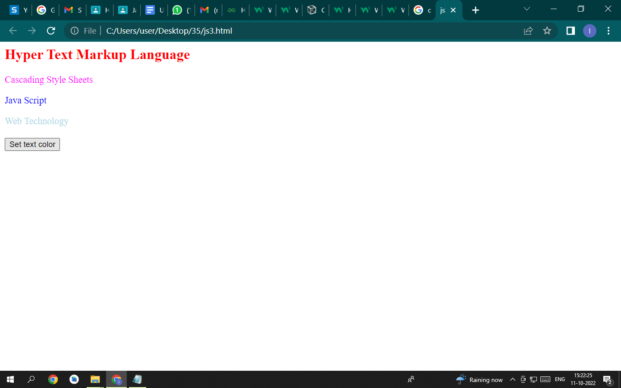

**Question 4:**

<!DOCTYPE html>

<html>

<body>

<h1>Alert Box: alert()</h1>

<script>

alert("This is an alert message box."); // display string message

</script>

</body>

</html>

<!DOCTYPE html>

<html>

<body>

<h1>Confirm Box: confirm()</h1>

<p id="msg"></p>

<script>

var userPreference;

if (confirm("Do you want to save changes?") == true) {

userPreference = "Data saved successfully!";

} else {

userPreference = "Save Canceled!";

}

document.getElementById("msg").innerHTML = userPreference;

</script>

</body>

</html>

<!DOCTYPE html>

<html>

<body>

<h1>Prompt Box: prompt()</h1>

<p id="msg"></p>

<script>

var tenure = prompt("Please enter preferred tenure in years", "15");

document.getElementById("msg").innerHTML = "You have entered " + tenure + " years";

</script>

